**What is Light GBM?**

Light GBM is a fast, distributed, high-performance gradient boosting framework based on decision tree algorithm, used for ranking, classification and many other machine learning tasks.

Since it is based on decision tree algorithm, it splits the tree leaf wise with best fit whereas other boosting algorithms split the tree depth wise or level wise rather than leaf-wise. So, when growing on the same leaf in Light GBM, the leaf-wise algorithm can reduce more loss than the level-wise algorithm and hence results in much better accuracy which can rarely be achieved by any of the existing boosting algorithms.

Also, it is suprisingly very fast, hence the word ‘Light’.

Before is a diagrammatic representation by the makers of the Light GBM to explain the difference clearly.

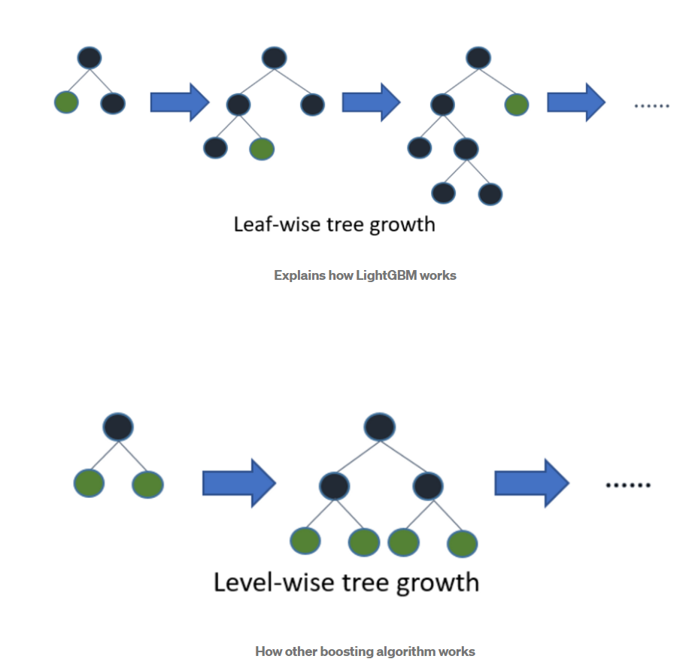

Level-wise tree growth in XGBOOST

Leaf wise splits lead to increase in complexity and may lead to overfitting and it can be overcome by specifying another parameter max-depth which specifies the depth to which splitting will occur.

**Advantages of Light GBM**

**Faster training speed and higher efficiency:** Light GBM use histogram-based algorithm i.e, it buckets continuous feature values into discreate bins which fasten the training procedure.

**Lower memory usage:** Replaces continuous values to discreate bins which results in lower memory usage.

**Better accuracy than any other boosting algorithm:** It produces much more complex trees by following leaf wise split approach rather than a level-wise approach which is the main factor in achieving higher accuracy. However, it can sometimes lead to overfitting which can be avoided by setting the max_depth parameter.

**Compatibility with Large Datasets:** It is capable of performing equally good with large datasets with a significant reduction in training time as compared to XGBOOST.

**Parallel learning supported.**